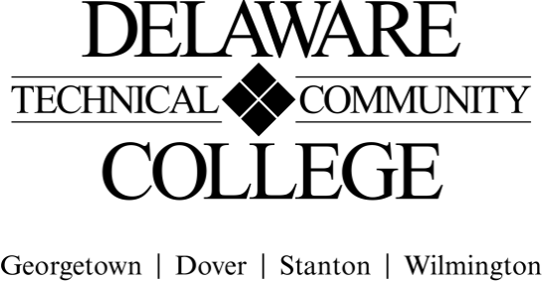
Course Evaluation Measures Menu

Course number: | CHM 110
Course title: | General Chemistry
Campus location(s): | Georgetown, Dover, Stanton, Wilmington
Effective semester: | 202652

Core Course Performance Objectives
- Perform numeric measurements to correctly solve chemical math problems. (CCC 1, 2,6)
- Describe the structure of matter at the atomic and molecular level. (CCC 1, 2, 6)
- Analyze the different types of chemical reactions. (CCC 1, 2, 6)
- Contrast the properties of gases, liquids, solids, and solutions. (CCC 1, 2, 6)
- Perform molar, stoichiometric, and gas law calculations. (CCC 2, 6)
- Describe acids, bases, and buffers, and perform calculations used to evaluate them. (CCC 1, 2, 6)
- Describe simple organic compounds, including properties, names, structures, and formulas. (CCC 2, 6)
- Explain nuclear radiation and decay. (CCC 1, 2, 6)
- Perform and analyze various laboratory activities related to chemistry. (CCC 1, 2, 3, 4, 5, 6)

Summative Evaluations
Please note: All courses must have a minimum of four summative evaluation measures, and those measures should include a variety of evaluation methods (e.g., test, oral presentation, group project). Please list all summative evaluation measures. In addition to these summative measures, a variety of formative exercises/quizzes/other assignments should be used to guide instruction and learning but do not need to be included on this template.

For each measure, please include a scope of the assignment: for example, if requiring a research paper, include the range of required number of words and number and types of sources; for a test, include the types and number of questions; for a presentation, include the minimum and maximum time, and so on.

Evaluation Measures: Include each agreed upon measure and scope of that measure (see above). | Which CCPO(s) does this evaluation measure?
Exams: 4-6; equally weighted  - 20-40 questions  - Selected response and written response | 1, 2, 3, 4, 5, 6, 7, 8

FINAL COURSE GRADE
(Calculated using the following weighted average)

Evaluation Measure | Percentage of final grade
Summative Assessments
Exams (equally weighted) | 65%
Formative Assessments
Lab assessments | 25%
Various formative assessments including but not limited to: quizzes, assignments, homework | 10%
TOTAL | 100%

Submitted by (Collegewide Lead): | Laura Bianco | Date | 11/6/25
Approved by counterparts |  | Date | 11/5/25
Reviewed by Curriculum Committee |  | Date | 1/6/26

