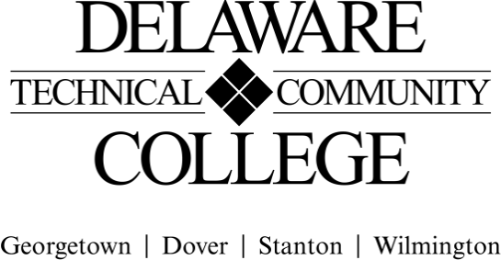
Course Evaluation Measures Menu

Course number: HRI 210
Course title: Beverage Management
Campus location(s): Dover, Georgetown, Stanton, Wilmington
Effective semester: 202151

Core Course Performance Objectives
1. Describe the overall beverage industry, including its history and its current state, as well as its future outlook in various hospitality venues. (CCC 1; PGC 4, 6)
2. Summarize the legal controls and the typical issues and consequences that relate to the beverage industry and responsible alcohol service. (CCC 1, 2, 3, 4, 6; PGC 4, 6)
3. Distinguish among the categories of alcoholic beverages, including variety, origin, ingredients, method of production, and trends on menus. (CCC 1, 5; PGC 4, 6)
4. Describe typical bar personnel and management functions, bar operations, bar types, bar equipment, and the creation and maintenance of a bar business. (CCC 1, 2, 3, 6; PGC 1, 3)
5. Analyze and develop beverage purchasing and pricing strategies, and document proper beverage storage techniques. (CCC 1, 2, 5, 6; PGC 4, 6)
6. Describe beverage employee activities related to hiring, training, customer service, inventory, and theft control. (CCC 1, 2, 3, 4, 6; PGC 4, 6)

Summative Evaluations

Evaluation Measures: | CCPO(s)
3-5 Tests: 5-40 written/multiple choice/true false, questions and fill-in  - Spirits  - Beer and wine  - Bar Management  - Other current topics | 1, 2, 3, 4, 5, 6
Final Comprehensive Exam: 25-50 written/multiple choice/true false questions and fill-in answer | 1, 2, 3, 4, 5, 6
Research Assignments: (2)  - Beverage Trend article (approx. 750 words or 1.5 pages)  - Spirits Presentation | 1, 3, 5

Beverage Management Project to include:  - An Outline or Concept  - Business Proposal  - List Mapping Plan  - Beverage Menu | 3, 4, 5, 6
- ServSafe® Alcohol certification exam  - Delaware Commissioner’s Rules’ Test | 1, 2, 3

FINAL COURSE GRADE

Evaluation Measure | Percentage of final grade
Quizzes, Homework, Journal (Formative) | 5%
Tests (Equally Weighted, Summative) | 25%
Final Comprehensive Exam (Summative) | 20%
Assignments: (Summative)  Beverage Trend  Spirits Presentation | 5%  10%
Beverage Management Project (Summative) | 15%
ServSafe Responsible Alcohol exam (Summative)  Delaware Commissioner’s Rules’ Test (Summative) | 15%  5%
TOTAL | 100%

(Electronic Signature Permitted)

Submitted by (Collegewide Lead): | Chala Breen | Date | 6/10/19
Approved by counterparts | Celeste Mozeik, Richard Rexrode | Date | 6/13/19
Reviewed by Curriculum Committee |  | Date

