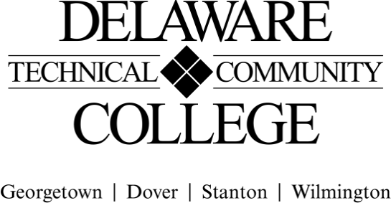

Course Evaluation Measures Menu

Course number: MET 225
Course title: Adv. Manufacturing Techniques
Campus location(s): Stanton

Core Course Performance Objectives
1. Identify metal finishing processes. (CCC 1, 2, 5; PGC MET 1, 8; PGC DEM 5)
2. Use typical machine shop equipment. (CCC 1, 2, 3, 4, 6; PGC MET 1, 5; PGC DEM 1, 2,
4, 5)
3. Perform selected welding and joining processes. (CCC 1, 2, 3, 4, 5; PGC MET 1, 5, 8; PGC DEM 1, 2, 4, 5)
4. Identify plastics and composites and their properties. (CCC 1, 2, 3, 4, 5; PGC MET 1, 5, 8; PGC DEM 1, 2, 4, 5)
5. Describe and use computer integrated manufacturing (CIM) and computer numerical control (CNC) processes. (CCC 1, 2, 5, 6; PGC MET 2, 3, 4; PGC DEM 1, 2, 4, 5)
6. Describe common heat treatment processes. (CCC 1, 2, 5; PGC MET 1, 8; PGC DEM 1, 2, 5)
7. Describe non-traditional machining. (CCC 1, 2, 5; PGC MET 1, 8; PGC DEM 1, 2, 5)
8. Explain types of competitive manufacturing such as lean, just-in-time (JIT), Six Sigma, Kanban, and Kaizen. (CCC 1, 2, 5; PGC MET 1, 5; PGC DEM 1, 2, 5)
9. Explain the applications of bulk deformation processes such as forming, rolling, drawing, and extrusion. (CCC 1, 2, 5; PGC MET 5; PGC DEM 1, 2, 5)
10. Determine the appropriate allowances and tolerances for fits using standard American National Standards Institute (ANSI) B4.1 (or B4.2 as applicable) for the assembly of mating parts. (CCC 1, 2, 6; PGC MET 1, 6, 10; PGC DEM 1, 2, 5)

Summative Evaluations
Please note: All courses must have a minimum of four summative evaluation measures, and those measures should include a variety of evaluation methods (e.g., test, oral presentation, group project). Please list all summative evaluation measures. In addition to these summative measures, a variety of formative exercises/quizzes/other assignments should be used to guide instruction and learning but do not need to be included on this template.

For each measure, please include a scope of the assignment: for example, if requiring a research paper, include the range of required number of words and number and types of sources; for a test, include the types and number of questions; for a presentation, include the minimum and maximum time, and so on.

CCPO | Evaluation Measures: Include each agreed upon measure and scope of that measure (see above).
- Identify metal finishing processes. | Test 1 – 8 Questions
- Use typical machine shop equipment. | Project 1, 2, 3 & 4
- Perform selected welding and joining processes. | Project 4  Test 4 – Welding – 19 Questions
- Identify plastics and composites and their properties. | Test 3 – 9 Questions
- Describe and use computer integrated manufacturing (CIM) and computer numerical control (CNC) processes. | Project 3 (Assembly)
- Describe common heat treatment processes. | Test 2 – 11 Questions
- Describe non-traditional machining. | Test 3 – 4 Questions
- Explain types of competitive manufacturing such as lean, just-in-time (JIT), Six Sigma, Kanban, and Kaizen. | Project 3 (Assembly)
- Explain the applications of bulk deformation processes such as forming, rolling, drawing, and extrusion. | Test 3 – 8 Questions
- Determine the appropriate allowances and tolerances for fits using standard American National Standards Institute (ANSI) B4.1 (or B4.2 as applicable) for the assembly of mating parts. | Project 3 (Assembly)  Test 2 – 15 Questions

FINAL COURSE GRADE
(Calculated using the following weighted average)

Evaluation Measure | Percentage of final grade
Tests 1-4 (equally weighted) (summative) | 50%
Project 1 (formative) | 7.5%
Project 2 (formative) | 7.5%
Project 3 (formative) | 30%
Project 4 – Welding (formative) | 5%
TOTAL | 100%
(Electronic Signature Permitted)

Submitted by (Collegewide Lead): __________________________________ Date __________________

Approved by counterparts Date ___________________

Reviewed by Curriculum Committee Date ___________________

