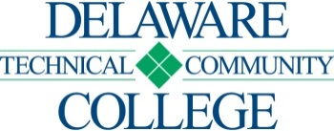
CAMPUS LOCATION: Georgetown COURSE SEQUENCE SHEET
Curriculum: Aviation Maintenance Technology-General/Airframe Maintenance Curriculum Code Designation: AVICERAFC
Effective: 2027-51

Name: |  |  | [ ] No developmental education requirements |  | [ ] MAT 052  [ ] MAT 062  [ ] MAT 099
  [ ] ENG 011
ID#:
Matriculation Date:

 |  |  |  |  | SEMESTER
COURSE NUMBER AND TITLE | Credits | Lecture |  | Lab | Offered | Completed | Grade | PREREQUISITES |  |  | COREQUISITES

FIRST SEMESTER
AVI 110 Airframe Maintenance General | 15 | 11 | 12 |  |  |  | SSC 100 or concurrent, ELC 102 or concurrent
ELC 102 Electronic Devices/Circuits I | 4 | 3 | 2 |  |  |  | SSC 100 or concurrent, AVI 110 or concurrent
TOTAL | 19 | 14 | 14

SECOND SEMESTER
AVI 120 Airframe Maintenance AF-Section I | 17 | 11 | 17 |  |  |  | AVI 110
TOTAL | 17 | 11 | 17

THIRD SEMESTER
AVI 210 Airframe Maintenance  AF- Section II | 17 | 11 | 19 |  |  |  | AVI 120, ELC 102
TOTAL | 17 | 11 | 19
GRAND TOTAL | 53 | 36 | 50

Date

